DAY 13 - PRIVILEGE & ACCESS CONCEPTS ASSESSMENT
Project: Local Lab Analysis
Target Machine: Metasploitable 2 (192.168.56.102)
Analyst: Urooj

1. LEAST PRIVILEGE ASSESSMENT

Command Used:
whoami; id

Output:
whoami: msfadmin
uid=1000(msfadmin) gid=1000(msfadmin) groups=4(adm),20(dialout),24(cdrom),25(floppy),29(audio),30(dip),44(video),46(plugdev),107(fuse),111(lpadmin),112(admin),119(sambashare),1000(msfadmin)

Observation:
The current user msfadmin (uid=1000) is a member of more than 12 groups including highly privileged groups like admin and adm. According to the Least Privilege Principle, a normal user should not have membership of administrative groups. This is a clear violation of Least Privilege.

2. MISCONFIGURATIONS FOUND

Command Used:
sudo -l

Output:
[sudo] password for msfadmin:
User msfadmin may run the following commands on this host:
(ALL) ALL

Analysis:
This is the most critical misconfiguration found in the system. The user msfadmin has been granted (ALL) ALL sudo privileges, which means he can run any command as root without any restriction. An attacker who compromises this low-privilege account can directly become root by running 'sudo su'. This is an ideal condition for Local Privilege Escalation (LPE).

3. SECURITY BOUNDARIES

Command Used:
cat /etc/shadow

Output:
cat: /etc/shadow: Permission denied

Analysis:
The system is maintaining a basic security boundary by denying direct access to the sensitive file /etc/shadow for a normal user. This shows that the kernel-level file permission boundary is working. However, this boundary is weak because it can be easily bypassed using the sudo misconfiguration found above.

4. LOCAL PRIVILEGE ESCALATION (LPE) - CONCEPT & RISK

Risk Level: CRITICAL

Attack Path:
Step 1: Attacker gains access as msfadmin (via weak password/brute force)
Step 2: Attacker checks privilege with 'sudo -l'
Step 3: Sees (ALL) ALL permission
Step 4: Runs 'sudo su' and becomes ROOT user

Impact:
Full System Compromise. Once root, attacker can create new users, delete logs, install backdoors, and access all data.

5. RECOMMENDATIONS

1. Remove (ALL) ALL entry from sudoers file. Give only required commands.
2. Remove user msfadmin from unnecessary groups like admin, adm, lpadmin.
3. Follow Least Privilege Principle strictly.
4. Enable auditing for all sudo activities.

CONCLUSION

The target system does not follow the Least Privilege Principle. Due to the sudo misconfiguration, the risk of Local Privilege Escalation is CRITICAL and needs immediate remediation.

Proofs Attached:
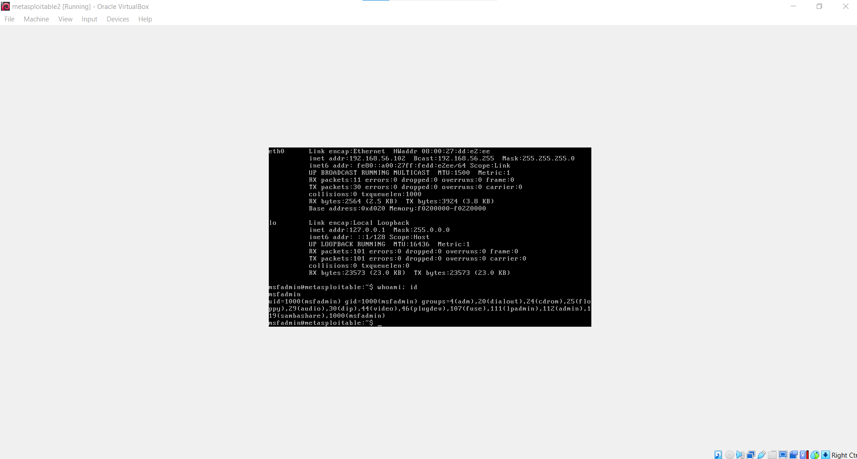: whoami; id result
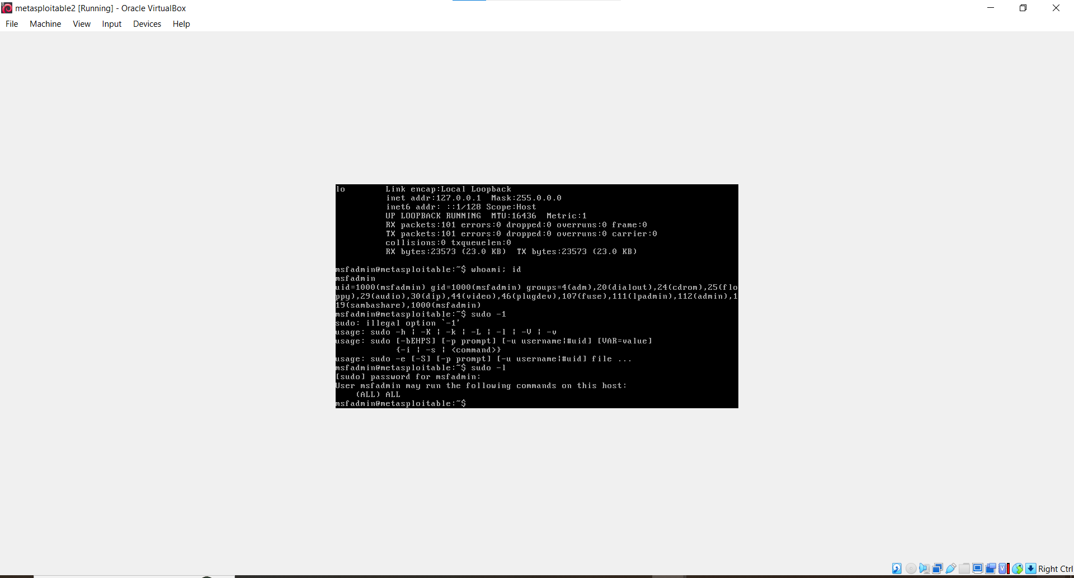: sudo -l result showing (ALL) ALL
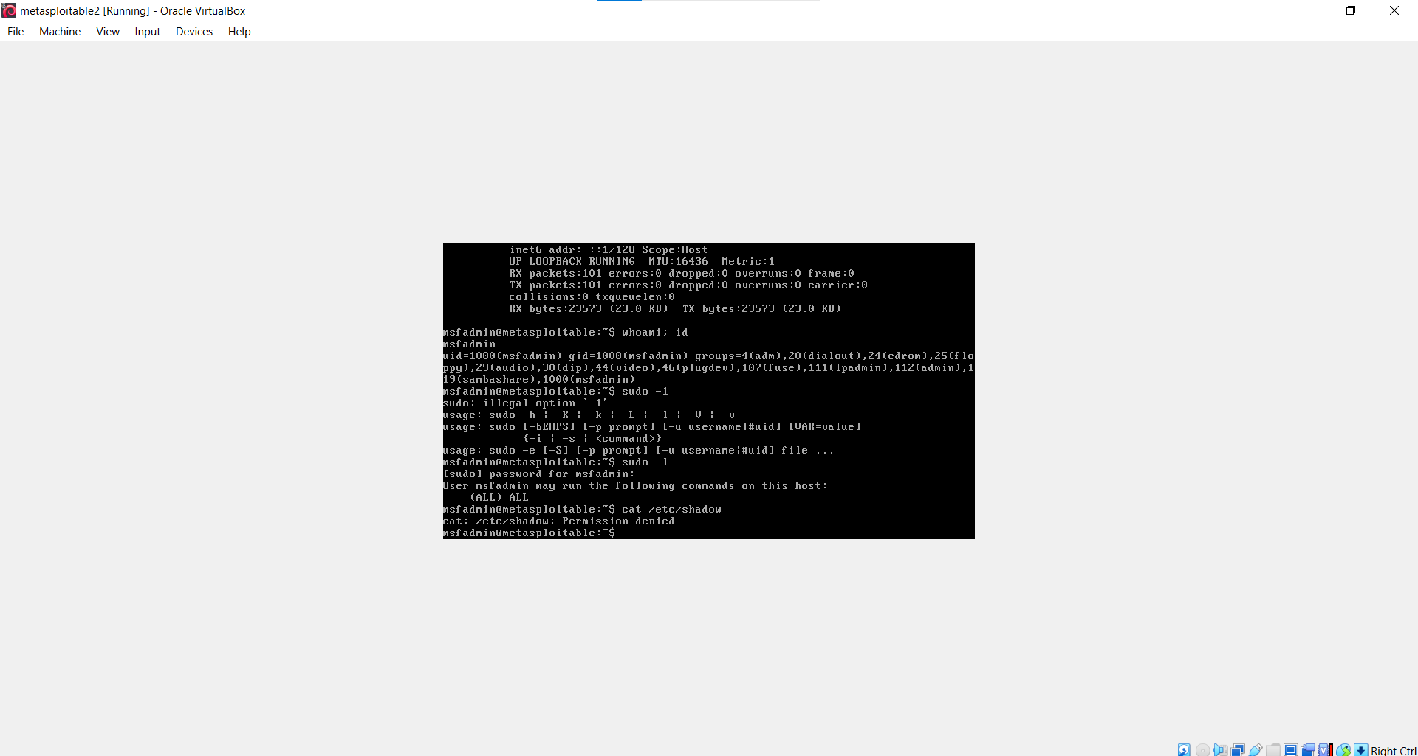: cat /etc/shadow Permission denied

